ADDENDUM TO THE SOCIETY FOR ENDOCRINOLOGY EMERGENCY GUIDANCE

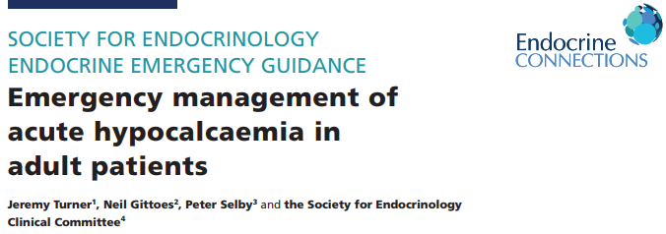

- The severe hypocalcaemia section of this guidance currently reads:

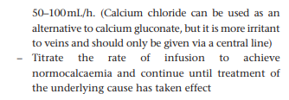
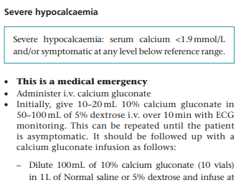

- The following addendum has been approved by the Society for Endocrinology Clinical Committee and the original authors.
Advice on dose equivalence of calcium gluconate and calcium chloride:
Each 10 mL vial of 10% calcium gluconate contains 2.2 mmol of calcium. Calcium chloride for intravenous administration is available in a number of formats including, commonly, 10 mL of 7.35% which contains 5 mmol of calcium and 5 mL of 14.7% (also containing 5 mmol of calcium). Great care should be taken since other preparations are also available. If using calcium chloride in place of calcium gluconate, 4.4 mL of 7.35% or 2.2 mL of 14.7% Calcium chloride for intravenous administration should therefore be used as equivalent to 10 ml of 10% calcium gluconate. If other calcium chloride preparations are used the required volume should be calculated aiming to achieve 2.2 – 4.4 mmol IV loading bolus followed by 1.1 – 2.2 mmol/hour maintenance infusion.

