Association of British Clinical Diabetologists & Society for Endocrinology Position Statement
Shape of Training: Endocrinology & Diabetes Specialty Training

The population of patients with type 2 diabetes and obesity has significantly increased in recent years. Furthermore, the management of complex endocrine and diabetes patients has become increasingly specialised, and requires considerable specialist expertise and regular exposure to complexity. Insulin pump therapy, continuous glucose monitoring and islet transplants are becoming more common pathways in type 1 diabetes. Endocrine diseases encompass both very common and rare/very rare conditions, which can only be managed by a specialist with sufficient expertise and experience.
Thus, training in complex specialist endocrinology diagnostics and treatment, including the long-term consequences of cancer treatment and survival, requires extensive exposure to develop pattern recognition, in order to achieve improvements in the morbidity and mortality associated with these less common diseases. In addition, 1 in 6 hospital inpatients now have diabetes1. It is critical that there is a skilled workforce capable of meeting the needs for specialist management in these patients, both now and in the future.
As a non-procedure-based specialty, Endocrinology & Diabetes specialty training is compromised by the demands of service provision for inpatient general medicine. Whilst this adds to the GIM competencies, trainees miss out on opportunities to attend specialist clinics2, equivalent to procedural training in other specialties. Furthermore, the lack of protected specialty time can be a deterrent to talented junior clinicians, and thus have an impact on recruitment. For 2018, only 39% of all National Training Numbers in E&D were filled in the first recruitment round3.
The proposed JRCPTB model for physician training in group 1 specialties (including Endocrinology & Diabetes), comprises three years of Stage 1 training in Internal Medicine (IM), followed by four years (minimum) dual training in specialty and IM. The specialty training will comprise three years (minimum) in specialty, with a further year of IM flexibly incorporated, as illustrated by Figure 14.

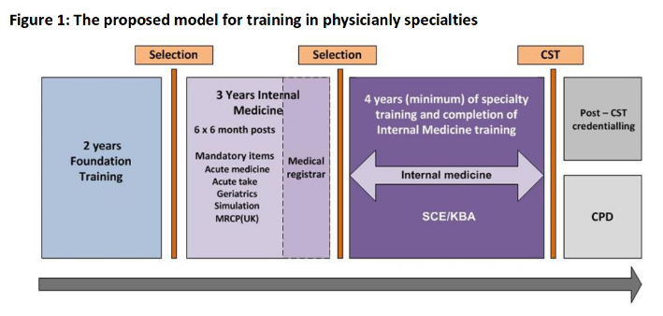
Both the Association of British Clinical Diabetologists and the Society for Endocrinology are concerned for the state of the specialty in future decades, and its ability to provide expert care. We therefore recommend that Endocrinology & Diabetes specialty training must include a minimum of two years (or equivalent) of protected specialty time, with no IM commitment during this time. Trainees will then be able to focus on acquiring expertise and experience in their specialist field. Stipulating a minimum period of dedicated training will also go some way to address the marked regional variation in training opportunities2. We suggest that the protected time is scheduled in such a way that IM competencies are up-to-date in the transition to consultant, but acknowledge that some regional variation may be inevitable here.
1NHS Digital. National Diabetes Inpatient Audit (NaDIA) – 2017. https://digital.nhs.uk/data-and-information/publications/statistical/national- diabetes-inpatient-audit/national-diabetes-inpatient-audit-nadia-2017
2Joint Royal College of Physicians Training Board. 2017 National Trainee Survey. https://www.jrcptb.org.uk/sites/default/files/2017%20Endo%20and%20Diabetes%20SSQs%20v2%2018.09.17.pdf
3Royal College of Physicians. ST3 Recruitment 2018. http://www.st3recruitment.org.uk/specialties/endocrinology-diabetes
4Joint Royal College of Physicians Training Board. Shape of Training: Response to the Academy of Medical Royal Colleges mapping exercise. October 2015. https://www.jrcptb.org.uk/sites/default/files/AoMRC%20mapping%20exercise%20JRCPTB%20Final%20Response%20_0.pdf

