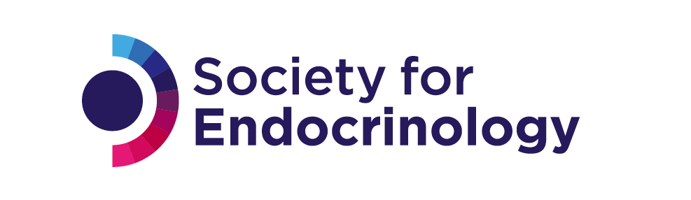

Application form for Endorsement of an Event

Please consult the Society for Endocrinology’s Endorsement policy when preparing this application.

Name of organisation applying for endorsement

Address

Name of applicant

Telephone contact number

Email address

Event details

Event name

Date of event

Does the event clash with any SfE events
http://www.endocrinology.org/meetings/

Funding / sponsoring organisation

Area of specialism

Name of Society for Endocrinology member(s) on the programme organising committee

Please list all members of organising committee

50 word summary of event including relevance to endocrinology and target audience. Please attach details of the final programme (we recognise that speakers may change)

Other organisations who have been approached for endorsement
Web link for supplementary information (if relevant)

Application date

Please send the application form and programme to endorsements@endocrinology.org
By submitting this application, I agree to the terms relating to events in the Endorsement policy
Privacy details
In order to evaluate your application, the data that you submit via this form will be shared with the review panel, relevant Society members and staff working for the Society for Endocrinology. We will store your data securely and only authorised personnel will be able to access it.
If your application is unsuccessful we will delete your application data from our systems one year after application. If your application is successful, we will hold your application data for 7 years for administration purposes and any subsquent impact reporting.

Updated March 2020

