Resource-limited treatment of thyrotoxicosis during the COVID-19 pandemic

How do we diagnose and treat thyrotoxicosis with limited resources?
Where possible, the diagnosis of thyrotoxicosis should continue to be made based on clinical suspicion, supported by typical biochemistry results. In liaison with primary care, endocrinologists will provide support in the form of advice and guidance letters, telephone advice, virtual outpatient clinics or face-to-face appointments, as dictated by the clinical urgency and availability of staff resources.

Over the coming weeks to months, it may become difficult or impossible to undertake biochemical monitoring of thyrotoxicosis; in this exceptional circumstance, we suggest that a “block and replace regimen”, obviating ongoing monitoring of TFTs, is considered. This regimen is designed to “block” hormone production from the thyroid gland, and then “replace” thyroid hormone by addition of thyroxine once the patient is euthyroid. In the majority of thyrotoxic patients, it allows euthyroidism to be achieved and maintained, irrespective of aetiology.

A suggested block and replace regimen is outlined in Figure 1 below. Resumption of thyroid function testing should be undertaken as soon as practicable. In all cases, patients should be referred to local endocrine services. If patients develop significant symptoms whilst being treated according to the algorithm, thyroid function should be tested and the case discussed with an endocrinologist, who can advise on further management.

Figure 1. Algorithm for management of thyrotoxicosis in resource limited setting.

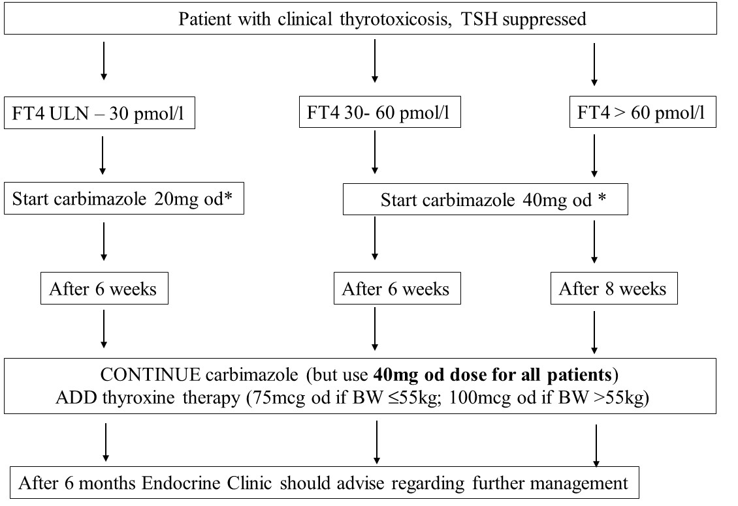
ULN; upper limit of normal, BW; body weight. *If carbimazole is commenced, the patient should be informed regarding potential side effects, including birth defects, agranulocytosis and abnormal liver function. Guidance on how to advise and manage patients with suspected agranulocytosis during COVID-19 can be found here in ‘Management of thyroid dysfunction’.

