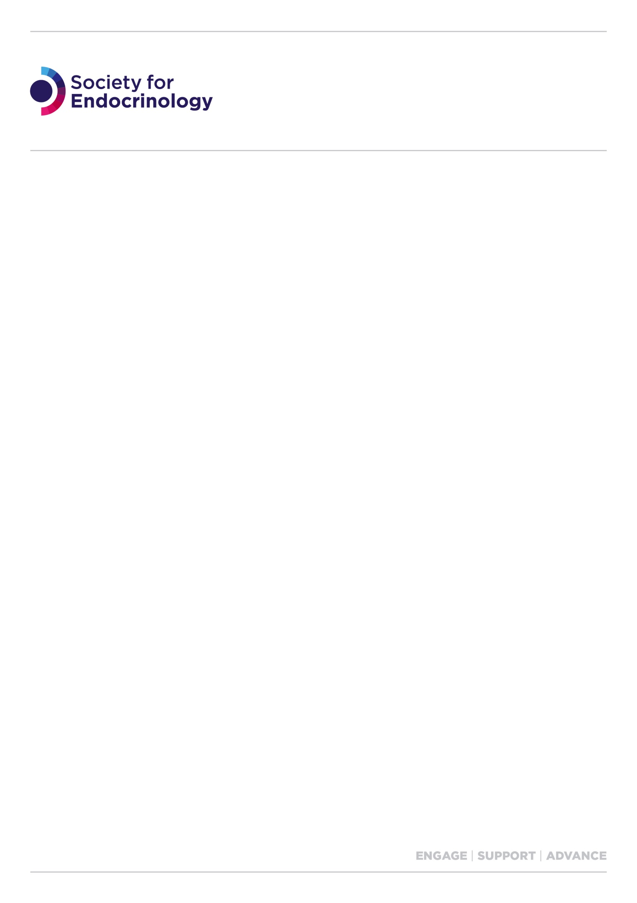

## **Clinical Update strand convenor job description**

Clinical Update is an annual three day residential event aimed at specialist registrars and newly appointed consultants. Strand convenors have a key role to play in working with the Clinical Update Lead Convenor to organise and deliver the scientific programme.

Over a three-year period, the programme delivers lectures and interactive workshops and covers the endocrinology components of the national curriculum in endocrinology and diabetes issued by the Joint Royal Colleges of Physicians Training Board. It provides excellent preparation for the Federation of Royal Colleges of Physicians’ Specialty Certificate Examination in Endocrinology and Diabetes and focusses on discussing best clinical practice based on day-to-day case scenarios.

The event runs as part of the Society for Endocrinology Endocrine Academy and parallel to Endocrine Nurse Update. Nurse delegates join Clinical Update delegates at plenary lectures and during catering breaks. During the workshops, nurses attend their own parallel sessions.

__________________________________________________

**Term of office:** 3 years

**Key responsibilities**

* Attend 1-2 meetings of the programme organising group – these are normally held during Clinical Update or online
* Organisation and delivery of a small group workshop of around 50 delegates, which is targeted to a specific topic on the curriculum. Each workshop is repeated 5 times over 3 days and should be as interactive as possible
* Recruit up to two facilitators per year to assist in the running of the workshop.
* Before the event, select suitable cases for presentation during the workshop; the cases are submitted to the office by prospective delegates and should consist of regularly encountered issues.

**Required input**

* Attend the whole event and its associated social events to enable networking
* Deliver the strand workshop with the assistance of facilitators. Each workshop is repeated 5 times over 3 days
* Chair the plenary lectures, if required
* Attend 1-2 meetings of the programme organising group promoting full participation of convenors (these meetings are normally held during Clinical Update or online.
* Respond in a timely manner to Clinical Update business conducted by email.
* Promote and act in the best interests of the Society at all times.

**Required skills**

* Understanding of the challenges faced by clinical members of the Society.
* Understanding of the endocrinology components of the national curriculum in endocrinology and diabetes.
* Ability to effectively lead small-group case-led teaching workshops
* Ability to listen to different perspectives and to challenge ideas constructively.
* Commitment to the aims and values of the Society and willingness to act as an ambassador.
* Clear understanding of equality, diversity and unconscious bias.

**Relationship to Society office**

The office handles all the administration associated with the event and its scientific programme.

The Society will cover the costs associated with your registration and accommodation and economy travel to and from the event. Reimbursement of your economy travel to and from the event will be made upon submission of an expense claim form with associated receipts.