
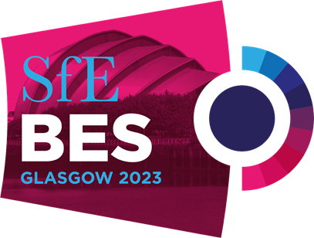
Official Forwarding
& Handling Tariff

SfE BES 2023 | Harrogate | 13 – 15 November 2023

Pos. | Customs Clearance Formalities |  |  |  |  |  | £ Sterling
1 | Customs clearance formality Permanent or temporary Import |  |  |  |  |  | 145.00
2 | Each additional tariff headings (first 2 headings included in pos 1.) |  |  |  |  |  | 10.00
3 | Customs Bond Fee (Temporary Importation) 3 % on CIF Value Minimum |  |  |  |  |  | 95.00
4 | Presentation to customs of Carnet A.T.A |  |  |  |  |  | 145.00
Pos. | Handling direct at venue ex truck on to Stand or ex Stand onto truck |  |  |  |  |  | £ Sterling
5 | Lifting for Unloading or Reloading per 1000 kgs or 3 cbm  Minimum  Chargeable weight is based on 1 cbm = 333 kilos  Trailer rate for full trailer stand building equipment |  |  |  |  |  | 34.00  75.00  575.00
Pos. | Storage |  |  |  |  |  | £ Sterling
6  7 | Collection/storage/and re-delivery of empty cases Min 2 cbm Per cbm  Full goods /Storage of brochures/consumables accessible Min 2 cbm Per cbm |  |  |  |  |  | 35.00  45.00
Pos. | Labour |  |  |  |  |  | £ Sterling
8 | Labour Minimum 4 hours per man/per hour |  |  |  |  |  | 28.00
Pos. | Handling via our Birmingham warehouse to or from stand |  |  |  |  |  | £ Sterling
9 | Receiving at warehouse and delivery to stand Per 100 kgs 1 cbm = 333 kgs Minimum |  |  |  |  |  | 18.00  125.00
10 | Courier shipments up to 20 kgs - Receiving, storage and stand delivery all inclusive |  |  |  |  |  | 75.00
Pos. | Other Costs |  |  |  |  |  | £ Sterling
11 | Order Processing Service Charge |  |  |  |  |  | 35.00
12 | Timed Deliveries within venue for symposiums (up to 100 kgs) |  |  |  |  |  | 95.00
13 | Insurance – Full transport insurance is available |  |  |  |  |  | Upon request
Pos. | Surcharges - Add to Items: |  | 5 |  | 8 | 9 |  | 10
 | After 17:00 hours week days / Saturdays | - | 50 % | - | 50 % | 50 % |  | 50 %
 | Sundays/Bank Holidays | - | 50 % | - | 50 % | 50 % |  | 50 %
Pos. | Important Notes
Charges are in £ Sterling and subject to VAT.

Please supply your Vat Number on our order form.

All charges for return shipments are according to above Inbound Tariff excluding handling of empties.

Any other services not covered by this tariff will be charged according to our expenses or by agreement.

All services must be either prepaid or paid at venue.

There are no credit facilities.

We accept VISA/MasterCard for orders received on site at venue.

All Business is transacted on BIFA Trading Conditions that exclude or limit the liability in certain
circumstances.

A copy is available on request or can be downloaded via our web site.



www.dhl.exh.com

